Two Week Challenge: Shades of Meaning
Week of: January 9 and January 16
Students need to be able to describe or use vivid words to tell their stories. I can model all day long, but I need your help to ensure they are using descriptive and interesting words when they are at home. This “Shades of Meaning” challenge is just the thing to get your child to use powerful words in their writing and speaking.
Activities:
Rewrite this paragraph using descriptive words.
Me and my friend went to the aquarium. It was a very big aquarium. There were big and little fish in the aquarium. It is home to seals, turtles, and sharks, too. We fed the fish and watched the scary sharks. I liked my trip to the aquarium. It was fun!

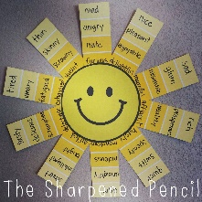
Read The Napping House and list all the ways the author describes how the characters are sleeping.
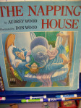
Using paints strips create your own
masterpiece. Use the following words:
sad, good, love, bad, short, tall,
boring and rich.

Draw 8 detailed pictures and then desribe them using strong adjectives.
Read food packaging at the grocery store or in your cupboard. Look for descriptive words that are used. Write them down on a note card and try using them in a conversation.

Create a wordle.
http://www.wordle.net/
Create your own Shades of Meaning activity.

Create a Google Slide Show
Use the following words:
sad, good, love, bad, short, tall,
boring and rich.

Each person in your family pick a word and come up with 5 stronger words to use instead of the word. (ex. small, little, short, teeny, mini, microscopic) Write each word on an index card then as a family put the words in order from weakest to strongest.

