C:\Documents and Settings\Kaitlyn\Local Settings\Temporary Internet Files\Content.IE5\96OLG97F\dglxasset[1].aspx





**DATE CHANGE:**

**Due to transportation issues we had to change the movie date again. I am very sorry for the inconvenience. The new and final date is Tuesday, April 25th. We will be leaving the school at 9:30am and expected to return at 1:30.**

**What are we learning this week?**

**Reading: We will be reading, Thunder, Elephant and Dorobo**

African folktale as told by Humphrey Harman

**Students will be able to:**

* Use strategies to prepare for reading (before reading).
* Use strategies to make meaning from the text (during reading).
* Use strategies to demonstrate understanding of the text (after reading).
* Develop comprehension skills through exposure to a variety of texts.
* Identify and describe the author’s use of language.

**Grammar:** homophones, homonyms, homographs, idioms, synonyms

**Vocabulary**: Shades of Meaning

**Writing:** TEA Paragraphs

**Math: Reviewing math skills**

**We will be reviewing previous chapters and standards as we have completed all topics and standards for 4th grade.**

**Social Studies: Economics**

**Science: Physical Changes in energy (MELTS)**

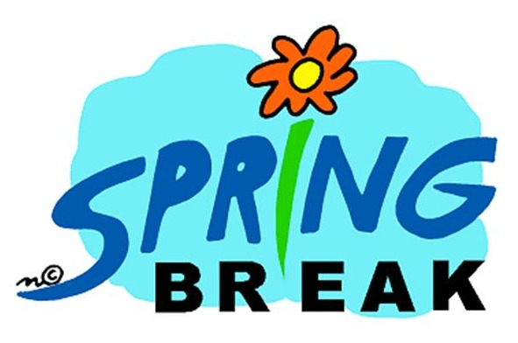

**Contact Information:** [**www.dilago.weebly.com**](http://www.dilago.weebly.com)

**Classroom: 321-633-3610**

**Cell: 321-543-2157**

**Email: dilago.aimee@brevardschools.org**

**Important Dates:**

**April 10-14~ Spring Break**

**April 18th/19th ~ ELA FSA**

**April 25th ~ Movie**

**May 4th/ 5th ~ Math FSA**

**May 8th ~ ISP Due**

**May 19th ~ Ice Plex**

Homework and any unfinished work from class is due the following day.

**Week of April 3, 2017**

Class News