C:\Documents and Settings\Kaitlyn\Local Settings\Temporary Internet Files\Content.IE5\96OLG97F\dglxasset[1].aspx

St. Augustine field trip is Tuesday. Students must be in the bus loop by 6:45. We will be leaving at 7:00. Please read over the form that was sent home last week about what students should and should not bring with them on the trip.

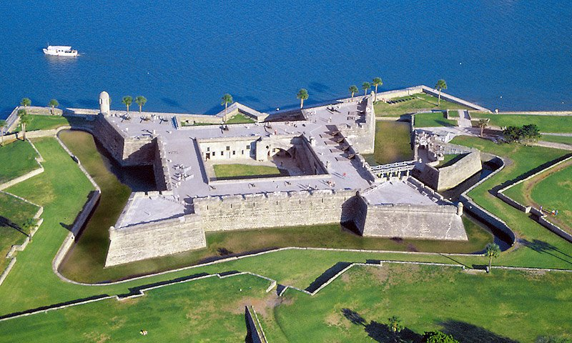

**What are we learning this week?**

**Reading: The Best Christmas Pageant Ever by Barbara Robinson** The Herdmans are the worst kids in the history of the world. They lie, steal, smoke cigars, swear, and hit little kids. So no one is prepared when this outlaw family invades church one Sunday and decides to take over the annual Christmas pageant. None of the Herdmans has ever heard the Christmas story before. Their interpretation of the tale -- the Wise Men are a bunch of dirty spies and Herod needs a good beating -- has a lot of people up in arms. But it will make this year's pageant the most unusual anyone has seen and, just possibly, the best one ever.

**Vocabulary**: contribution, hysterical, penitentiary, imitation, parable, congregation, snitching, sympathize, worshipped, supervise, vengeance, espoused, disgrace, instincts, chief, villain, parsonage, milling, refugees, confer, crookedy, collapsible, bewildered, underfoot

**Grammar:**

Greek and Latin roots

Root: aud, audi

Prefixes: (opposite) dis- anti- de- counter- contra-

Prepositions and Prepositional Phrases

adages and proverbs

**Writing:** informational text (HOT TEA POT)

**Math: TOPIC 10**

**In Class Homework from Workbook**

**Monday**  Topic 11.5  **Topic 11.5**

**Tuesday** Field Trip  **Field Trip**

**Wednesday** Topic 11.6 **Topic 11.6**

**Thursday**  Topic 11.7  **Topic 11.7**

**Friday**  Topic 11.8 **None**

**Please practice multiplication facts nightly.**

**Social Studies: Unit 3 Explain how the Seminole tribe formed and the purpose for their migration. Explain how Florida (Adams-Onis Treaty) became a US territory. Identify the cause and effects of the Seminole War.**

**Science: Earth/Space Science**

**Earth Structures: Describe the basic differences between physical weathering and erosion.**

**Important Dates:**

**Dec. 13 ~ St. Augustine Field Trip**

**Dec. 15 ~ ISP Due**

**Dec. 20 ~ Ugly Christmas Sweater**

**Dec. 22 – Jan. 6 ~ Winter Break**

**Science Fair Due Dates**

**November 7th ~ Question**

**November 14th ~ Research**

**November 21st ~ Hypothesis**

**November 28th ~ Materials/Procedures**

**December 5th ~ Data/Results**

**December 12th ~ Conclusion/Summary**

**December 19th ~ Complete Display**

**Contact Information:** [**www.dilago.weebly.com**](NULL)

**Classroom: 321-633-3610**

**Cell: 321-543-2157**

**Email: dilago.aimee@brevardschools.org**

Homework and any unfinished work from class is due the following day.

**Week of December 12, 2016**

Class News