C:\Documents and Settings\Kaitlyn\Local Settings\Temporary Internet Files\Content.IE5\96OLG97F\dglxasset[1].aspx

Homework will be assigned daily. Students will be writing it in their planner.

Pasta for Pennies Annual Charity Drive

Special Dates:

March 3rd PJ Day ($3)

March 10th Crazy Sock/Favorite Jersey($1)

March 18th Green Day

The class that collects the most money wins a pasta lunch from Olive Garden.

DR. Seuss Week

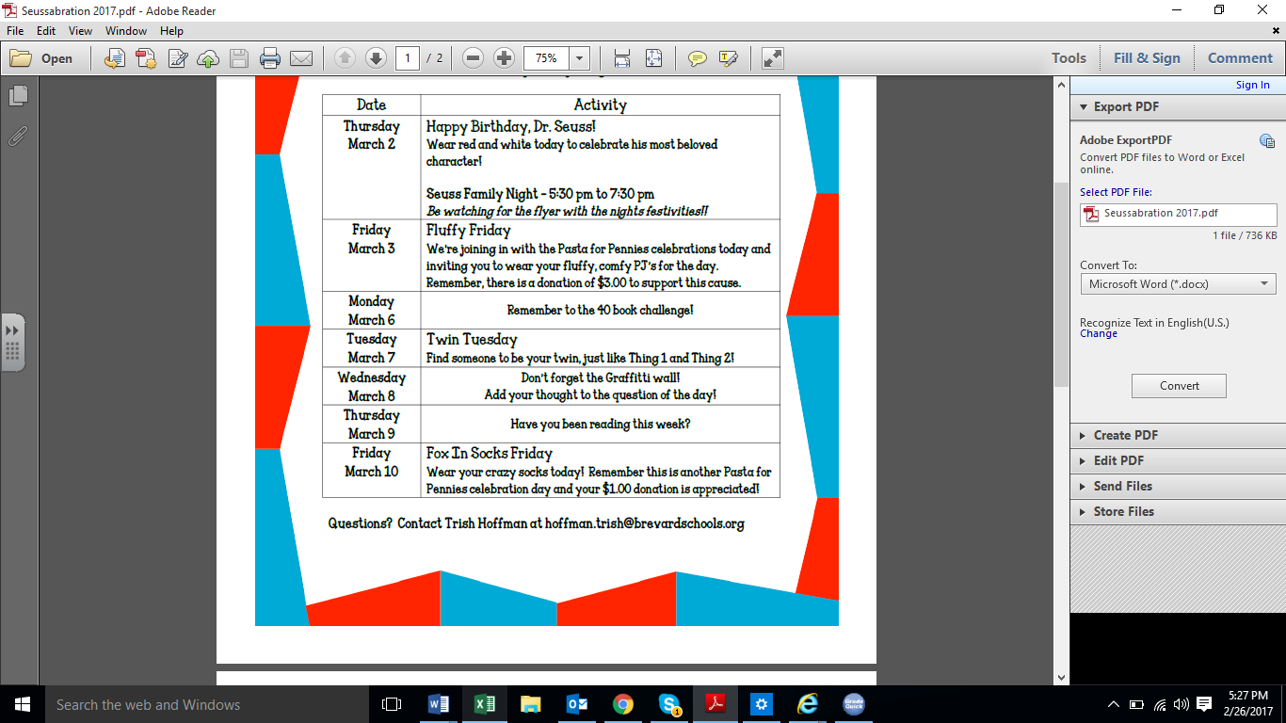

**Important Dates:**

**Feb. 28th ~ Writing FSA**

**Mar. 6th ~ ISP Due**

**April 18th ~ ELA FSA**

**Contact Information:** [**www.dilago.weebly.com**](http://www.dilago.weebly.com)

**Classroom: 321-633-3610**

**Cell: 321-543-2157**

**Email: dilago.aimee@brevardschools.org**

**What are we learning this week?**

**FSA Writing is on Tuesday. We have been practicing and the kids are ready! Please make sure your child gets a good night’s sleep and eats a well-balanced breakfast.**

**Reading: We will finish reading, The Watsons Go to Birmingham 1963**   
  
**Grammar:** onamonapia, similes and metaphors, complete sentences and punctuation

.**Writing:** attributions, introductions and conclusions

RACE and HOT TEA POT

**Math: TOPIC 15**

**In Class Homework from Workbook**

**Monday**

**Tuesday**

**Wednesday**

**Thursday**

**Friday**

**Please practice multiplication facts nightly.**

**Social Studies: Economics**

**Science: Physical**

Changes in energy.

We are scheduled to go see the movie, Born in China on Friday, May 12th and the Space Coast Ice Plex on Friday, May 19th. The total cost for both trips will be $25.00. Permission forms will be sent home this week.

Homework and any unfinished work from class is due the following day.

**Week of February 27, 2017**

Class News