C:\Documents and Settings\Kaitlyn\Local Settings\Temporary Internet Files\Content.IE5\96OLG97F\dglxasset[1].aspx

**Important Dates:**

**Feb. 28th ~ Writing FSA**

**Mar. 6th ~ ISP Due**

**Mar. 14th ~ End of 3rd Quarter**

**Mar. 21st ~ Report Cards**

**Mar. 22nd ~ Good Citizen**

**Mar. 30th ~ Commando**

**April 10-14~ Spring Break**

**April 18th/19th ~ ELA FSA**

**May 4th/ 5th ~ Math FSA**

Homework will be assigned daily. Students will be writing it in their planner.

Pasta for Pennies Annual Charity Drive

Special Dates:

March 3rd PJ Day ($3)

March 10th Crazy Sock/Favorite Jersey($1)

March 16th Green Day

The class that collects the most money wins a pasta lunch from Olive Garden.

DR. Seuss Week

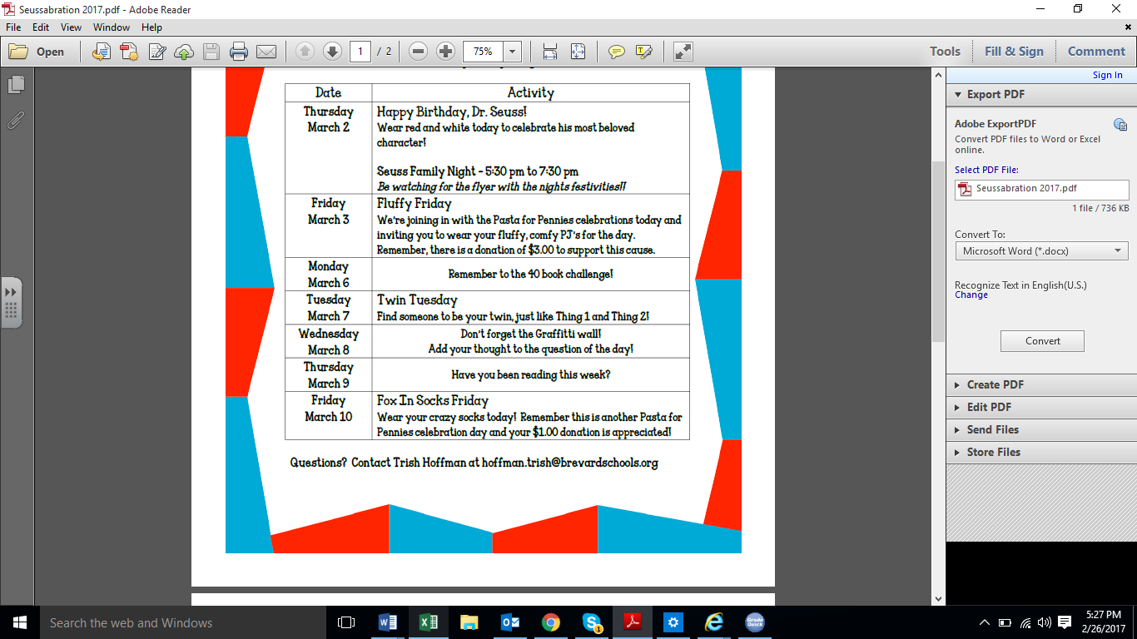

**What are we learning this week?**

**Reading: We will be reading Sacagawea and Native American Poetry**

**EQ: How do people from different cultures contribute to American History?**

**Grammar:** Abbreviations

**Vocabulary**: Shades of Meaning

.**Writing:** TEA Paragraphs

**Math: TOPIC 15 Review and Starting Topic 16**

**In Class Homework from Workbook**

**Monday**

**Tuesday**

**Wednesday**

**Thursday**

**Friday**

**Please practice multiplication facts nightly.**

**Social Studies: Economics**

**Science: Physical Changes in energy (MELTS)**

We are scheduled to go see the movie, Born in China on Friday, May 12th and the Space Coast Ice Plex on Friday, May 19th. The total cost for both trips will be $25.00. Permission forms will be sent home this week.

**Contact Information:** [**www.dilago.weebly.com**](http://www.dilago.weebly.com)

**Classroom: 321-633-3610**

**Cell: 321-543-2157**

**Email: dilago.aimee@brevardschools.org**

Homework and any unfinished work from class is due the following day.

**Week of March 6, 2017**

Class News