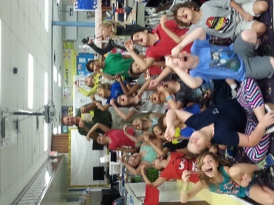 **­­­­­**

**What are we learning this week?**

**Reading: We will be continue reading Hatchet by Gary Paulsen**  
**Science: Physical Science-magnets**

**Math: We will be starting 4th grade Sunshine Math and Step It up to 5th Grade**

Field trip reminder: Tuesday 5/03, is our field trip to the Brevard County Manatee Stadium to see the Manatees play a baseball game. We will be gone from 9:45-1:45. Students will receive a lunch before the game starts and aren’t allowed to bring any other food into the stadium. Students **ARE** allowed and **HIGHLY** encouraged to bring a non-disposable water bottle to refill.

Students… please wear your white Andersen tee shirt (or a white tee or another color Andersen shirt), shorts, and closed toe shoes. Students may also bring sunglasses and a hat to wear. Please apply sunscreen at home. We will not be going to any of the concession stands so students do not need to bring any money. **They will not be given any opportunities to buy extras.**

Chaperones- We only have two buses so we are asking that chaperones follow the bus to the stadium.

**Contact Information:** [**www.dilago.weebly.com**](http://www.dilago.weebly.com)

**Classroom: 321-633-3610 ext. 5004**

**Cell: 321-543-2157**

**Email:** [**dilago.aimee@brevardschools.org**](mailto:dilago.aimee@brevardschools.org)

**If you would like to schedule a parent/teacher conference, please contact me.**

<http://www.donorschoose.org/we-teach/2526486>

**Activity:**

**Mon. Day 5 PE**

**Tues. Field Trip**

**Wed. Wonderful Wednesday**

**Thurs. Field Trip**

**Fri. D3 STEM**

**May 3rd** – Manatee Field Trip

**May 5th** – Canine Commandos

**May 13th** – Volunteer Breakfast

**May 24th** – Last day of School

Report Cards Issued

I want to thank you for letting me be a part of your child's education this past school year. I truly have enjoyed helping your child learn and grow, and I will miss them all next year.

**Week of May 2, 2016**

Class News