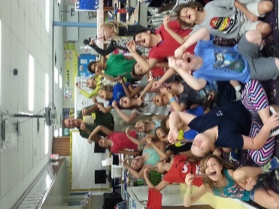 **­­­­­**

**What are we learning this week?**

**Reading: We will be reading, Bridge to Terabithia by Katherine Paterson**

All summer, Jess pushed himself to be the fastest boy in the fifth grade, and when the year's first school-yard race was run, he was going to win. But his victory was stolen by a newcomer, by a girl, one who didn't even know enough to stay on the girls' side of the playground. Then, unexpectedly, Jess finds himself sticking up for Leslie, for the girl who breaks rules and wins races. The friendship between the two grows as Jess guides the city girl through the pitfalls of life in their small, rural town, and Leslie draws him into the world of imagination-a world of magic and ceremony called Terabithia. Here, Leslie and Jess rule supreme among the oaks and evergreens, safe from the bullies and ridicule of the mundane world. Safe until an unforeseen tragedy forces Jess to reign in Terabithia alone, and both worlds are forever changed.

In this poignant, beautifully rendered novel, Katherine Paterson weaves a powerful story of friendship and courage.

**Science: Physical Science-magnets**

**Math: We will be starting 4th grade Sunshine Math and Step It up to 5th Grade**

**Contact Information:** [**www.dilago.weebly.com**](http://www.dilago.weebly.com)

**Classroom: 321-633-3610 ext. 5004**

**Cell: 321-543-2157**

**Email:** [**dilago.aimee@brevardschools.org**](mailto:dilago.aimee@brevardschools.org)

**If you would like to schedule a parent/teacher conference, please contact me.**

<http://www.donorschoose.org/we-teach/2526486>

**Activity:**

**Mon. Day 4 Art**

**Tues. Day 5 PE**

**Wed. Wonderful Wednesday**

**Thurs. Day 1 Music**

**Fri. Day 2 Media**

**May 13th** – Volunteer Breakfast

**May 24th** – Last day of School

Report Cards Issued

I want to thank you for letting me be a part of your child's education this past school year. I truly have enjoyed helping your child learn and grow, and I will miss them all next year.

**Week of May 9, 2016**

Class News