C:\Documents and Settings\Kaitlyn\Local Settings\Temporary Internet Files\Content.IE5\96OLG97F\dglxasset[1].aspx

**What are we learning this week?**

**Reading:** We will continue reading, SCAT by Carl Hiaasen. This week we will be reading chapters 17-22.

**Grammar:** Greek and Latin roots Root: photo (light) Prefixes: (not) non-, ir-, in-, im-, il-

**Writing:** informational text (HOT TEA POT)

**Math: TOPIC 9**

**We moved to Topic 9**

**In Class Homework from Workbook**

**Monday**  Topic 9.3  **Topic 9.3**

**Tuesday** Topic 9.4  **Topic 9.4**

**Wednesday** Topic9.5  **Topic 9.5**

**Thursday** Topic 9.6  **None**

**Friday** Holiday  **None**

**Please practice multiplication facts nightly. This is an area that many students are still struggling in. Ask your child what they get on their mad math minute, if they are below 30 they need additional practice at home.**

**Social Studies: Unit 2: Exploration and Colonization of Florida**

**Identify explorers who came to Florida and the motivations for their expeditions. Describe the causes and effects of European colonization on the Native American tribes of Florida. Identify the significance of St. Augustine as the oldest permanent European settlement in the US. Identify the effects of Spanish rule in Florida.**

**Science: We will continue our unit on the Indian River Lagoon (Life Science)**

**Vocabulary:** ALGAE, CRUSTACEANS, FOOD CHAIN, INLET, LIFECYCLE, PELICAN, SALTWATER, SPECIES, CANAL, ENDANGERED, FOODWEB, MANGROVE, PREDATORS, SEAGRASS, THREATENED, ONSERVATION, ESTUARY, HABITAT, LARVAE, ORGANISMS, PRESERVE, SEA WEED

TURBID

**St. Augustine permission forms were sent home on Thursday.**

**Cost $61 for students and $75 for chaperones.**

**Important Dates:**

**Nov. 10 ~ Fall Festival 5:00-7:30**

**Nov. 11 ~ Veteran’s Day Holiday**

**SkyZone Fundraiser for Relay for Life**

**Nov. 15 ~ Picture Retakes**

**Nov. 16 ~ Lagoon Field Trip**

**Nov. 23-25 ~ Thanksgiving Holiday**

**Dec. 13 ~ St. Augustine Field Trip**

**Dec. 15 ~ ISP Due**

**Dec. 22 – Jan. 6 ~ Winter Break**

**Science Fair Due Dates**

**November 7th ~ Question**

**November 14th ~ Research**

**November 21st ~ Hypothesis**

**November 28th ~ Materials/Procedures**

**December 5th ~ Data/Results**

**December 12th ~ Conclusion/Summary**

**December 19th ~ Complete Display**

**Contact Information:** [**www.dilago.weebly.com**](http://www.dilago.weebly.com)

**Classroom: 321-633-3610**

**Cell: 321-543-2157**

**Email: dilago.aimee@brevardschools.org**

**Canine Commando presents**

**A “Movie with your Pack” Night**

**Movie:** Steven Spielberg’s

Adventures of TinTin

**Where:** Viera Park

**Cost:** $10 family or $5 single

**When:** Saturday, November 19th at 6:30

I will have tickets available in the classroom.

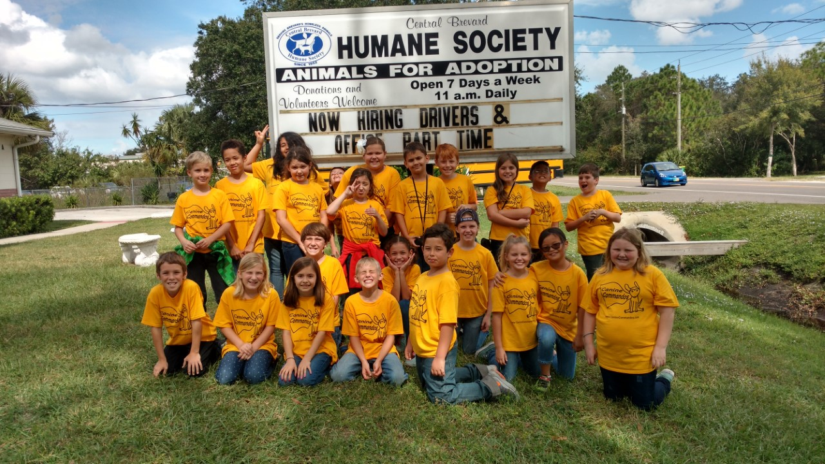

Homework and any unfinished work from class is due the following day.

**Week of November 7, 2016**

Class News