C:\Documents and Settings\Kaitlyn\Local Settings\Temporary Internet Files\Content.IE5\96OLG97F\dglxasset[1].aspx

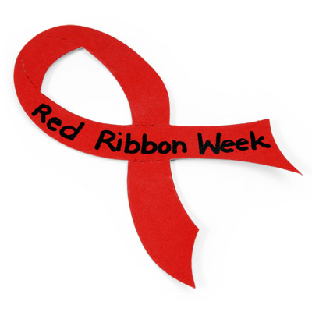

**RED RIBBON WEEK 2016**

“Let us celebrate being drug & Bully Free”

October 24th – 28th

Theme:

“Good Character, Good Choices

We are Drug & Bully Free!!”

Monday 10/24/16 – Be a “Jean”ius – Stay Drug Free

Wear jeans and a red shirt to kick off Red Ribbon Week

TUESDAY 10/25/16 – Team Up Against Drugs

Wear Team Jerseys

Wednesday 10/26/16 – Lei Off Drugs

Wear Hawaiian theme clothes

Thursday 10/27/16 – A healthy me is drug free

Wear athletic or exercise clothes

Friday 10/28/16 – My future looks great without drugs

Dress like who you want to be when you grow up

Ex. Doctor, Nurse, Military, Teacher etc.

**What are we learning this week?**

**Reading:** We will continue reading, SCAT by Carl Hiaasen. This week we will be reading chapters 7-12.

**Grammar:** Greek and Latin roots

We will be studying Greek and Latin roots. More than 70 percent of English comes from Latin and Greek word origins. When students learn 100 roots, they can figure out the meanings of 100,000 words. When students know the roots, they can be a word detective – figuring out the meaning of a word on their own.

This week’s roots: ante, anti, bi, com, and circum

**Math: TOPIC 6**

**In Class Homework from Workbook**

**Monday** Topic 7.1  **Topic 7.1**

**Tuesday** Topic 7.2  **Topic 7.2**

**Wednesday** Topic7.3  **Topic 7.3**

**Thursday** Topic 7.4  **Topic 7.4**

**Friday** Topic 7.5  **None**

**Social Studies: Unit 1: Florida’s Land and Early People**

**This week we will do our final project for Unit 1. We will be making our Florida salt maps.**

**Science: We will continue our unit on the Indian River Lagoon (Life Science)**

**Vocabulary:** ALGAE, CRUSTACEANS, FOOD CHAIN, INLET, LIFECYCLE, PELICAN, SALTWATER, SPECIES, CANAL, ENDANGERED, FOODWEB, MANGROVE, PREDATORS, SEAGRASS, THREATENED, ONSERVATION, ESTUARY, HABITAT, LARVAE, ORGANISMS, PRESERVE, SEA WEED

TURBID

**Important Dates:**

**Oct. 24 ~ Conference Night**

**Oct. 27 ~ Science Fair Night 5-7**

**Oct. 28 ~ Good Citizen Breakfast**

**Oct. 28 ~ Silly Sock/Hat Day $1**

**Nov. 3 ~ Canine Commando**

**STEM Night 5:30-7:30**

**Nov. 10 ~ Fall Festival**

**Nov. 11 ~ Veteran’s Day Holiday**

**SkyZone Fundraiser for Relay for Life**

**Nov. 16 ~ Lagoon Field Trip**

**Nov. 23-25 ~ Thanksgiving Holiday**

**Dec. 13 ~ St. Augustine Field Trip**

**Dec. 22 – Jan. 6 ~ Winter Break**

**Contact Information:** [**www.dilago.weebly.com**](http://www.dilago.weebly.com)

**Classroom: 321-633-3610**

**Cell: 321-543-2157**

**Email: dilago.aimee@brevardschools.org**

Homework and any unfinished work from class is due the following day.

**Week of October 24, 2016**

Class News